**BANK LOAN REPORT QUERY DOCUMENT**

1. **BANK LOAN REPORT | SUMMARY**

**KPI’s:**

select count(*) as Total_Application_ID from financial_loan;

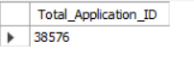

select count(id) as MTD_Total_Loan_Application from financial_loan

where month(issue_date) =12 and year(issue_date)=2021;

select count(id) as PMTD_Total_Loan_Application from financial_loan

where month(issue_date) =11;



select sum(loan_amount) as Total_Fund_Amount from financial_loan;

select sum(loan_amount) as MTD_Total_Fund_Amount from financial_loan

where month(issue_date)=12;

select sum(loan_amount) as PMTD_Total_Fund_Amount from financial_loan

where month(issue_date)=11;

Select sum(total_payment) as Total_Payment_Recevied from financial_loan;

Select sum(total_payment) as MTD_Total_Payment_Recevied from financial_loan

where month(issue_date)=12;



Select sum(total_payment) as PMTD_Total_Payment_Recevied from financial_loan

where month(issue_date)=11;

select Round(avg(int_rate),4) * 100 as Average_Interest_Rate from financial_loan;



select Round(avg(int_rate),4) * 100 as MTD_Average_Interest_Rate from financial_loan

where month(issue_date)=12;

select Round(avg(int_rate),4) * 100 as PMTD_Average_Interest_Rate from financial_loan

where month(issue_date)=11;

select Round(avg(dti),4) * 100 as Debt_to_Income from financial_loan;

select Round(avg(dti),4) * 100 as MTD_Debt_to_Income from financial_loan

where month(issue_date)=12;

select Round(avg(dti),4) * 100 as PTMD_Debt_to_Income from financial_loan

where month(issue_date)=11;

**GOOD LOAN ISSUED**

select

(count(case when loan_status = 'Fully Paid' or loan_status = 'Current' then id end))

/ count(id) *100 as Good_loan_Percentage

from financial_loan;



select count(id) as Good_loan_Application from financial_loan

where loan_status = 'Fully Paid' or loan_status = 'Current';



select sum(loan_amount) as Good_loan_Funded_Amount from financial_loan

where loan_status = 'Fully Paid' or loan_status = 'Current';



select sum(total_payment) as Good_loan_Received_Amount from financial_loan

where loan_status = 'Fully Paid' or loan_status = 'Current';



**BAD LOAN ISSUED**

select

(count(case when loan_status = 'Charged Off' then id end)*100)

/ count(id) as Bad_loan_Percentage

from financial_loan;



select count(id) as Bad_loan_Application from financial_loan

where loan_status='Charged Off';

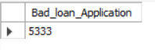

select sum(loan_amount) as Bad_loan_Funded_Amount from financial_loan

where loan_status ='Charged Off';



select sum(total_payment) as Bad_loan_Received_Amount from financial_loan

where loan_status = 'Charged Off';



**LOAN STATUS**

select loan_status,count(id) as Total_loan_Application,

sum(total_payment) as Total_Amount_Received,

sum(loan_amount) as Total_funded_Amount,

avg(int_rate * 100) as Avg_rate_Percentage,

avg(dti * 100) as Avg_dti_Percentage

from financial_loan

group by loan_status;

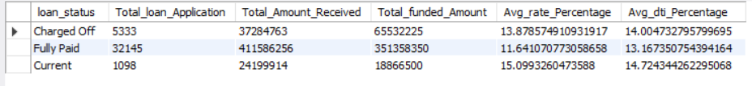

select loan_status,

sum(total_payment) as MTD_Total_Amount_Received,

sum(loan_amount) as MTD_Total_funded_Amount

from financial_loan

where month(issue_date) = 12

group by loan_status;

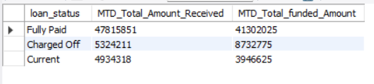

1. **BANK LOAN REPORT | OVERVIEW**

**MONTH**

select month(issue_date) as Month_No ,Date_Format(issue_date, '%M') as Month_Name,

count(id) as Total_Application,

sum(loan_amount) as Total_Amount_Funded,

sum(total_payment) as Total_Amount_Received

from financial_loan

group by Month_No,Month_Name

order by Month_No,Month_Name;

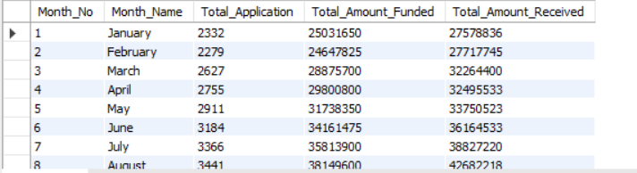

**STATE**

select address_state,

count(id) as Total_Application,

sum(loan_amount) as Total_Amount_Funded,

sum(total_payment) as Total_Amount_Received

from financial_loan

group by address_state

order by Total_Amount_Funded desc;

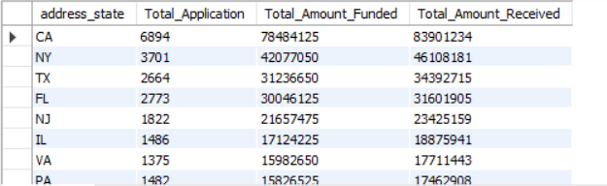

**TERM**

SELECT term AS Term,

COUNT(id) AS Total_Loan_Applications,

SUM(loan_amount) AS Total_Amount_Funded,

SUM(total_payment) AS Total_Amount_Received

FROM financial_loan

GROUP BY Term

ORDER BY Term

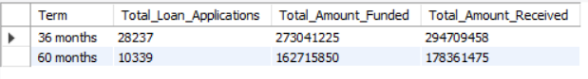

**EMPLOYEE LENGTH**

SELECT

emp_length AS Employee_Length,

COUNT(id) AS Total_Loan_Applications,

SUM(loan_amount) AS Total_Amount_Funded,

SUM(total_payment) AS Total_Amount_Received

FROM financial_loan

GROUP BY emp_length

ORDER BY emp_length

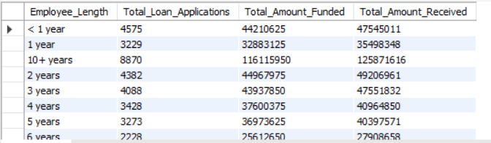

**PURPOSE**

select purpose,

count(id) as Total_Application,

sum(loan_amount) as Total_Amount_Funded,

sum(total_payment) as Total_Amount_Received

from financial_loan

group by purpose

order by Total_Amount_Funded desc;

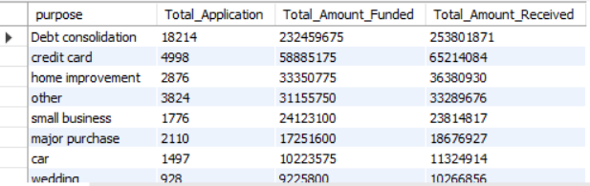

**HOME OWNERSHIP**

select home_ownership,

count(id) as Total_Application,

sum(loan_amount) as Total_Amount_Funded,

sum(total_payment) as Total_Amount_Received

from financial_loan

group by home_ownership

order by Total_Amount_Funded desc;

